S2 Project – Mobile App Development: Button Pressing Speed-Test (BPST)

You are a mobile app developer. In the coming few weeks, you are going to develop an App to test the button pressing speed of the player. We name the App as "BPST_mobile".

Structure: Screenshots are captured from https://www.clickspeedtest.info/spacebar-speed-test
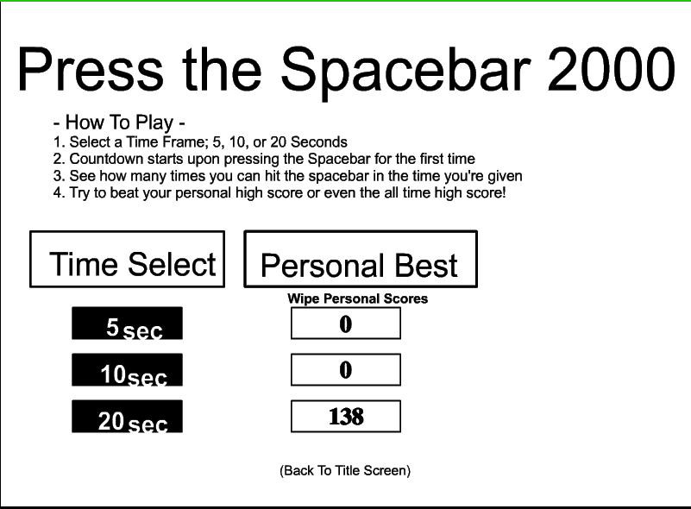  Screenshot 1: Main Screen (Screen1)  Player can choose the time limit. | 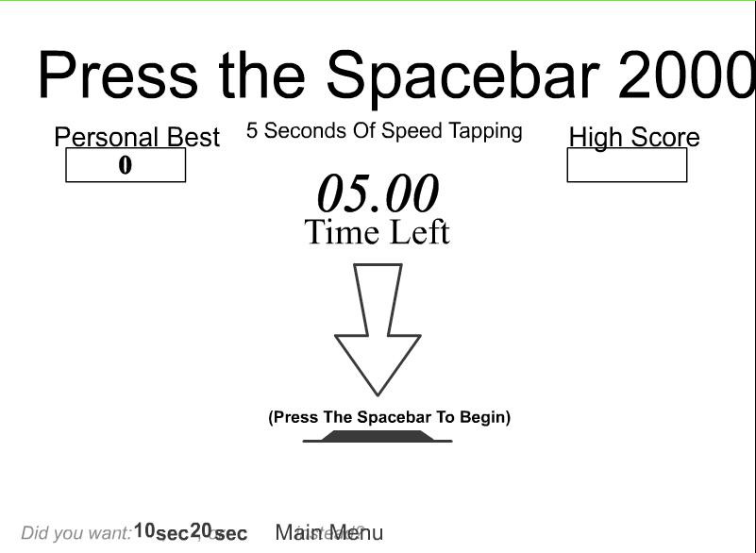  Screenshot 2: Testing Screen (Game)  Player can press the button to start the game.
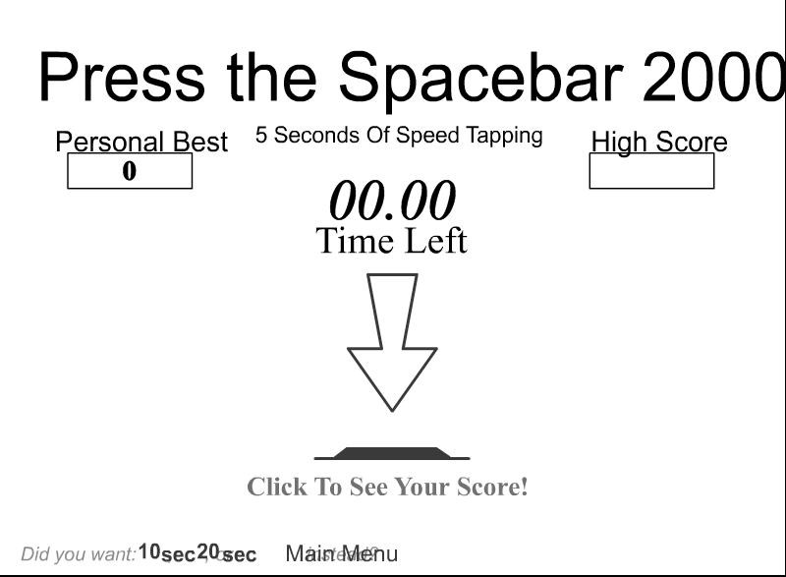  Screenshot 3: Testing Screen (Game)  Timer stops when time is up. | 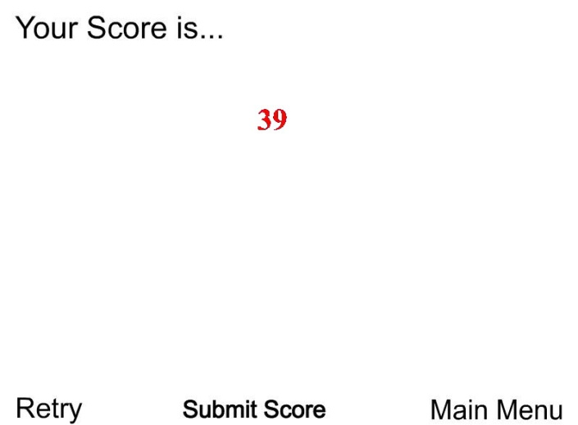  Screenshot 4: Result Screen (Score)  Player can see the score.

Technical requirements:
- At least 3 screen (Screen1, Game and Result). You can add more screen when necessary.
- All graphics used should be designed by you. Including:
  - Background Image
  - ALL buttons.
- User can select different time limit in the App.
- The App can count the number of button pressed.
- The App can show the result after the time is up.

Marking Scheme: Total 30 marks
(Good quality 5 marks; Medium quality 3 marks; Poor quality 1 marks; No attempt 0 mark)
Check Point | Description | Marks
3 Screens | - The App contains at least 3 screens (Screen1, Game and Result). | 5 marks
Backgrounds | - All background image of every screen should be the cartoon characters drawn by you. | 5 marks
Buttons | - All buttons should use the image designed by you. | 5 marks
Time Limit | - The App provides different time limit to the player. | 5 marks
Counting | - The App can count the number of the button being pressed. | 5 marks
Result | - The App can show the result. | 5 marks
Bonus | - All creatives design. | 5 marks

